Hua Hin Night Market
Time: | 17.00 to around 24.00
Orientation price: | 600 Baht / bus
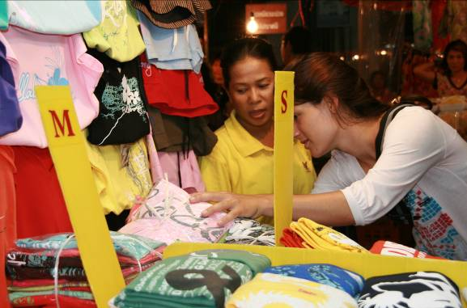
A “must” for everyone!

The night market is open every day of the
week from about 5 pm to midnight.
You will always find more than 100 booths
with clothes, souvenirs and food at the
Petchakasem Rd. and the Dechanuchit Rd.

There you can try local specialities and you can buy all kinds of useful and less useful things.

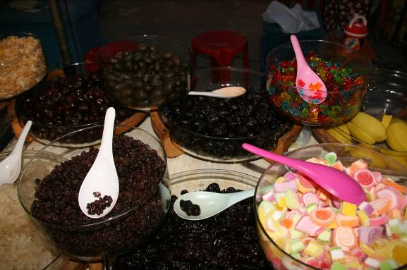
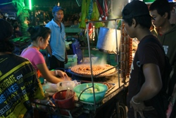
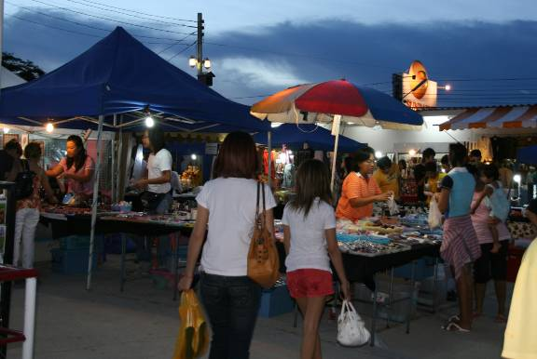
Tip: For a successful shopping experience at the night market, read the page “Restaurant & market” at the beginning of the booklet.

