Monkey-Mountain in Hua Hin
Time: | On demand
Orientation price: | 200 Baht / person
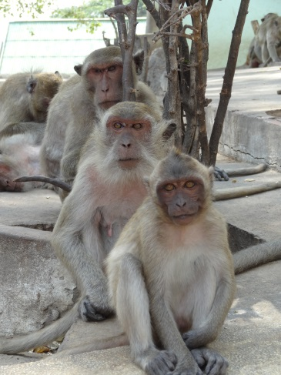
The monkey-mountain or „Khao Takiab“ is 4 km away from Hua Hin and about 3 km away from BNK Seaside. Khao Takiab can be reached by walking in a longer promenade. On this hill lives a colony of monkeys (Attention! Close all your bags, hold on to your camera, the monkeys can get very bold, do not take food with you). On the top of the mountain is a temple. From there you have a beautiful view over Hua Hin. At the bottom of the temple are different small shops to stroll with lovely and low-priced souvenirs.
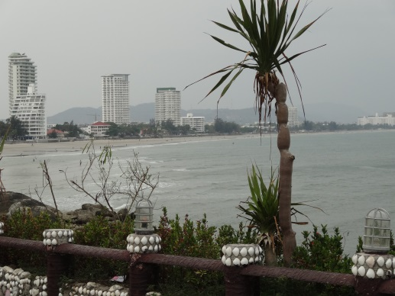
On the north side of the mountain stands a golden Buddha-statue in the rocks. For a long time it was a symbol for „Khao Takiab“.
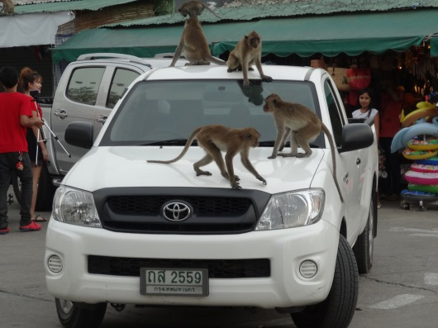
Around the mountain you can find a lot of seafood restaurants.

