„Silk Village“ – Tailor-made clothes
Orientation price: |  | 600 Baht / bus
Where: | 18/1 Naebkhehars Rd., Hua Hin
Opening hours: | Mo- Su, 9 am -6 pm
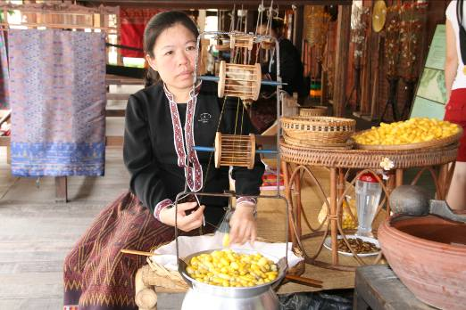

Silkworms, spinning wheel and weaving loom. The „Thai Silk Cultural Village“ lies north of the centre of Hua Hin, near the harbour and is conducted by the company “Mike & Co. Tailor”.

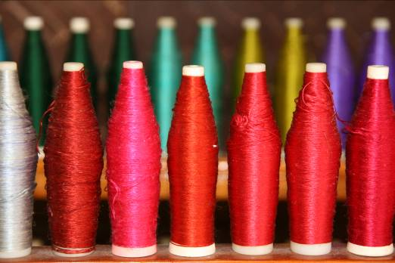
Also if you do not intend to have clothes tailored, the visit is still worthwhile. The craftsmen show their skill and a guide explains the procedure of silk production. Whoever would like to visit the shop can do so, but you are free not to do so.

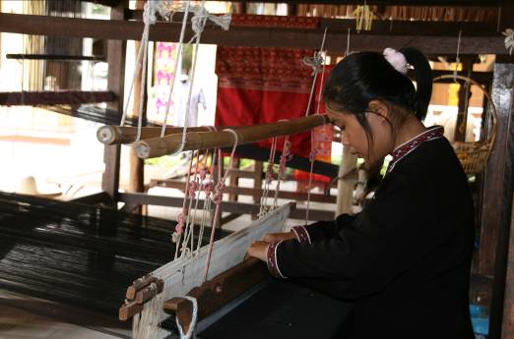
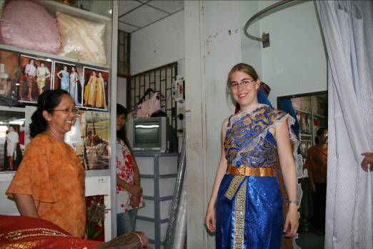
You will find many different tailor shops in Hua Hin which are relatively cheap (in comparison with Europe). They will tailor any dress you like in a very short time. It is worthwhile to take a look at different stores and then to choose.

